**Mint**

I really like the usability of the site, but I actually find the text hard to read and the color scheme jarring.

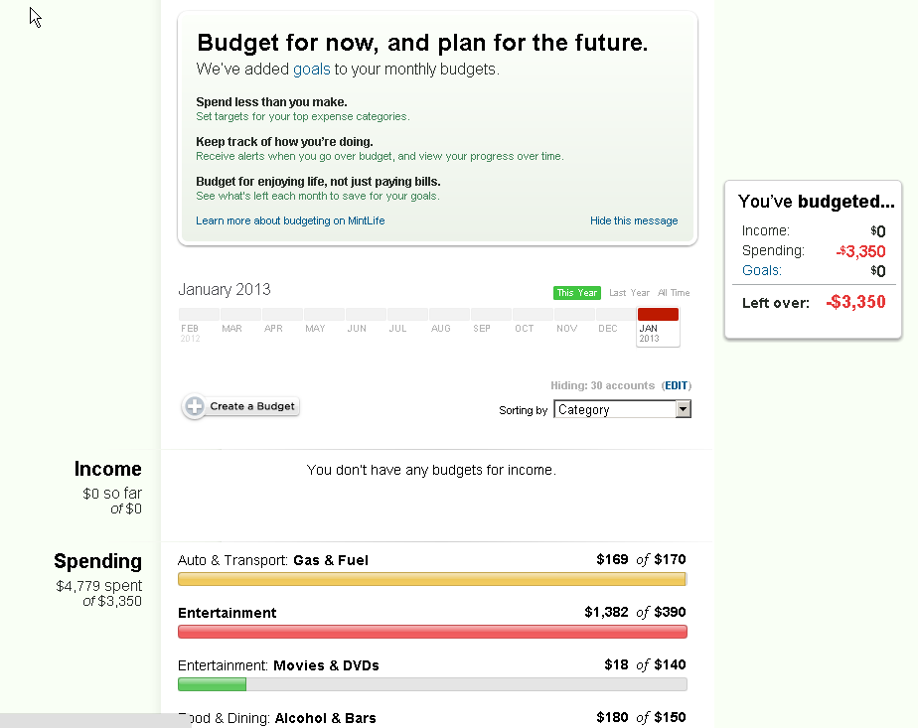

**Mozy**

I like how clean and uncluttered the interface is:

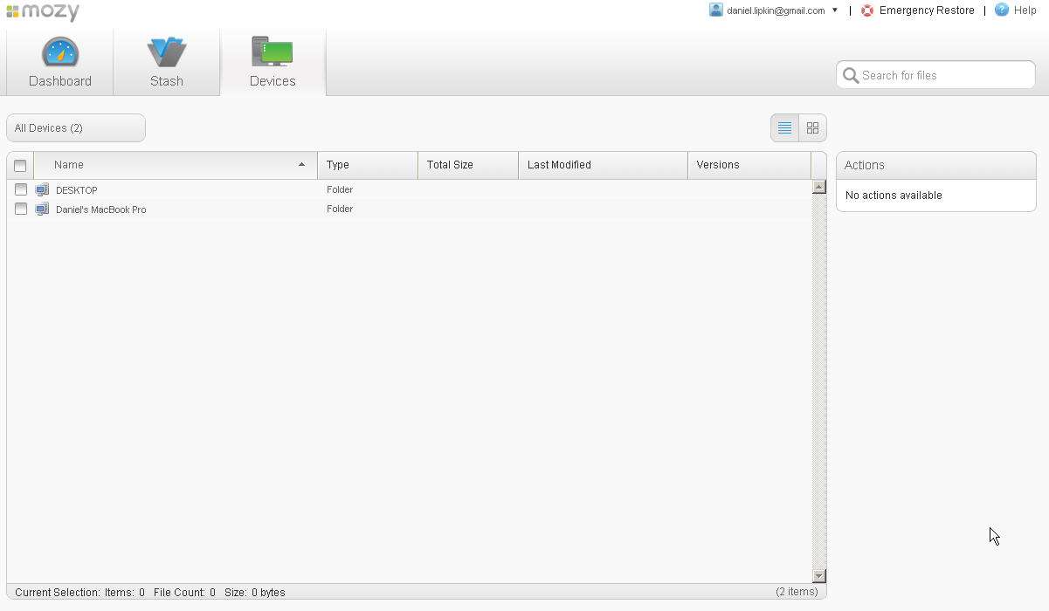

**Soluto**

This site has a very distinct visual style. I really like its approach to conveying complex information. The design is probably more whimsical than what we're going for.

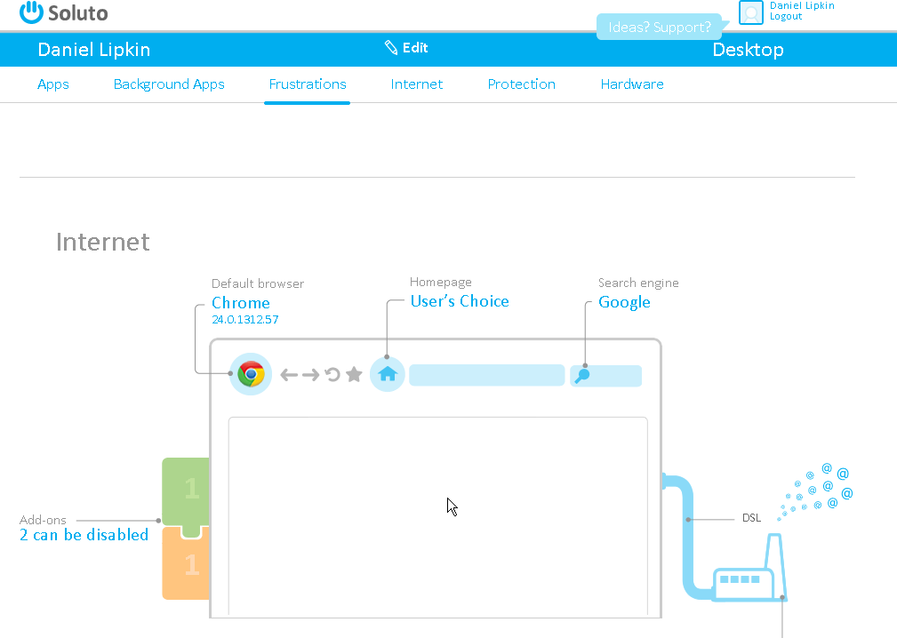

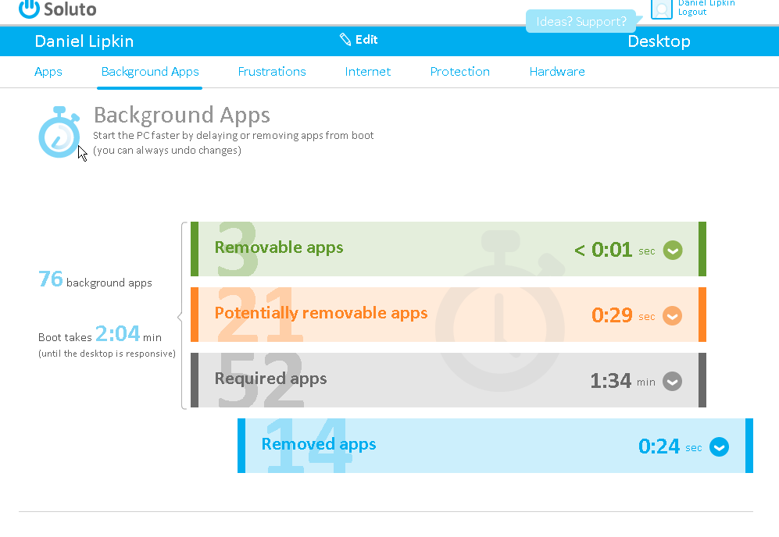

**Stripe**

Another really clean looking site.

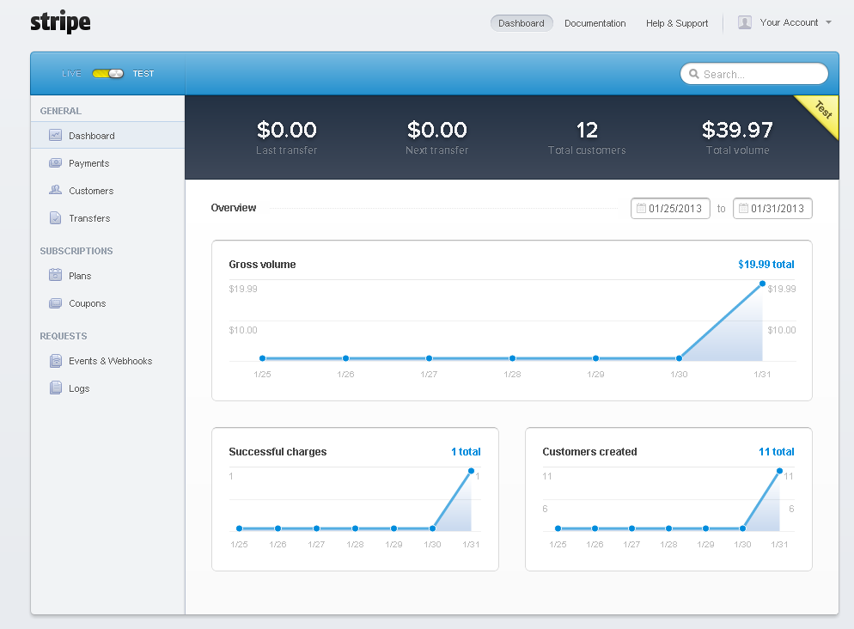

**SumAll**

It's worth checking out what they're doing - they have extremely complex visualizations but they make it easy to configure and play with the numbers.

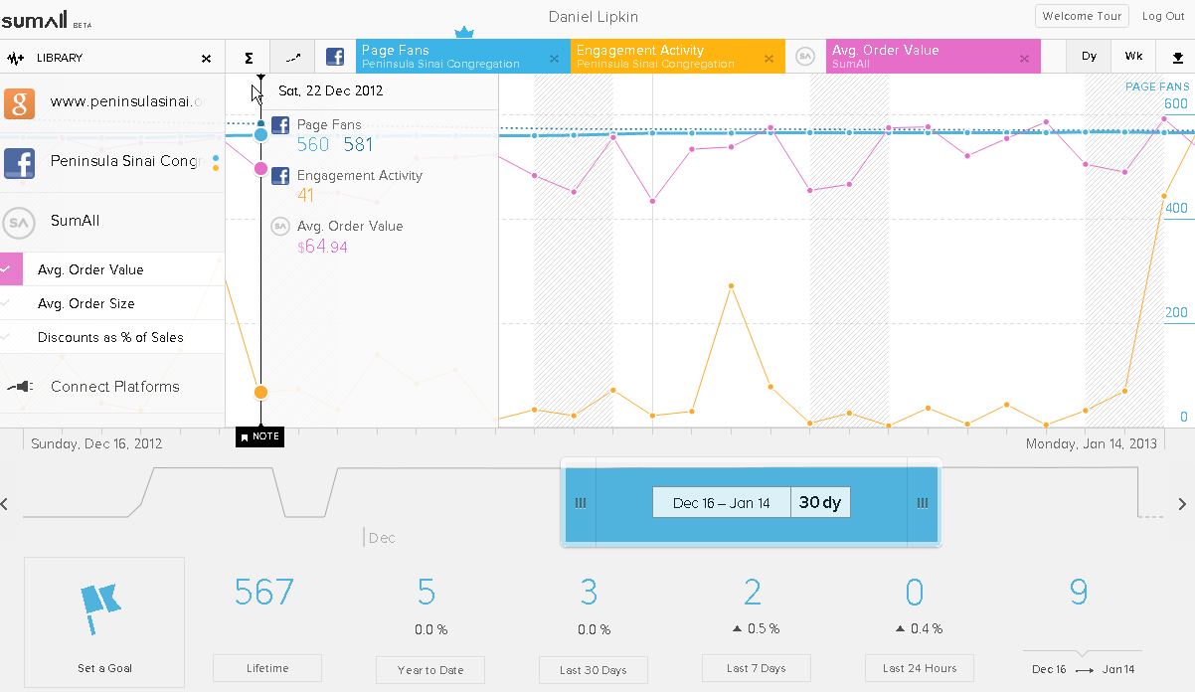

They also have a nice configuration screen in that it shows you what data it will pull in and even suggests different providers to compare with each other.

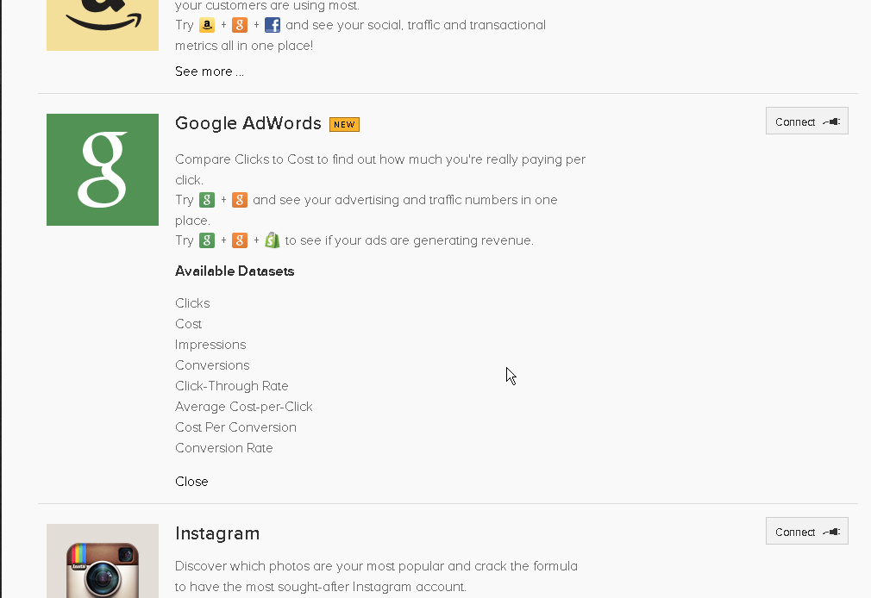

**Zapier**

Also very clean look & feel, and very well designed flows for connecting together two services. It's basically a wizard, but they've combined all the steps onto a single page.

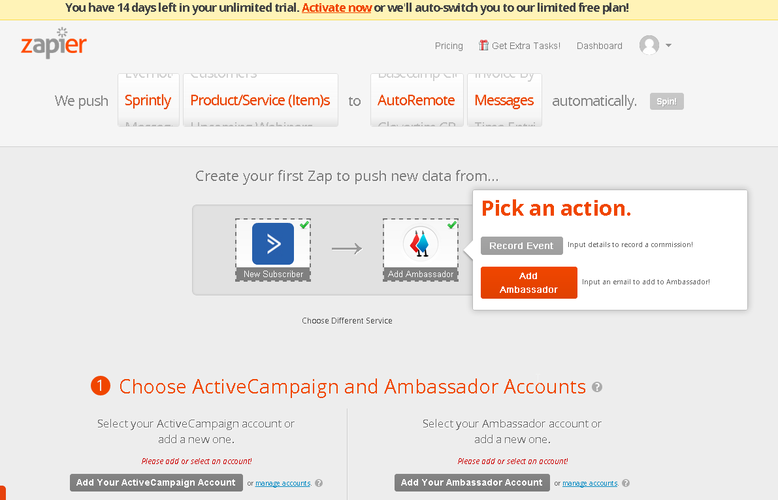

**Motif Investing**

Clean presentation of information and easy to read.

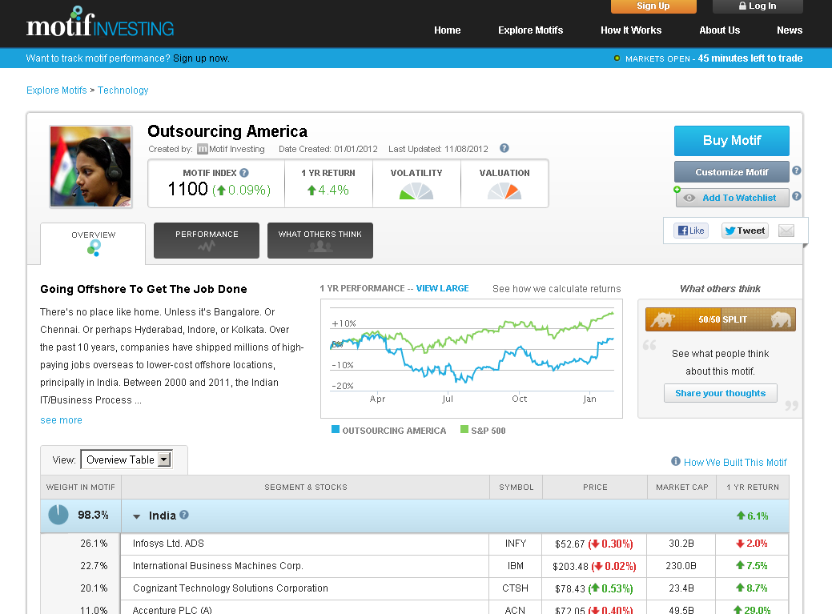

**Evernote**

Nothing fancy, very clean look.

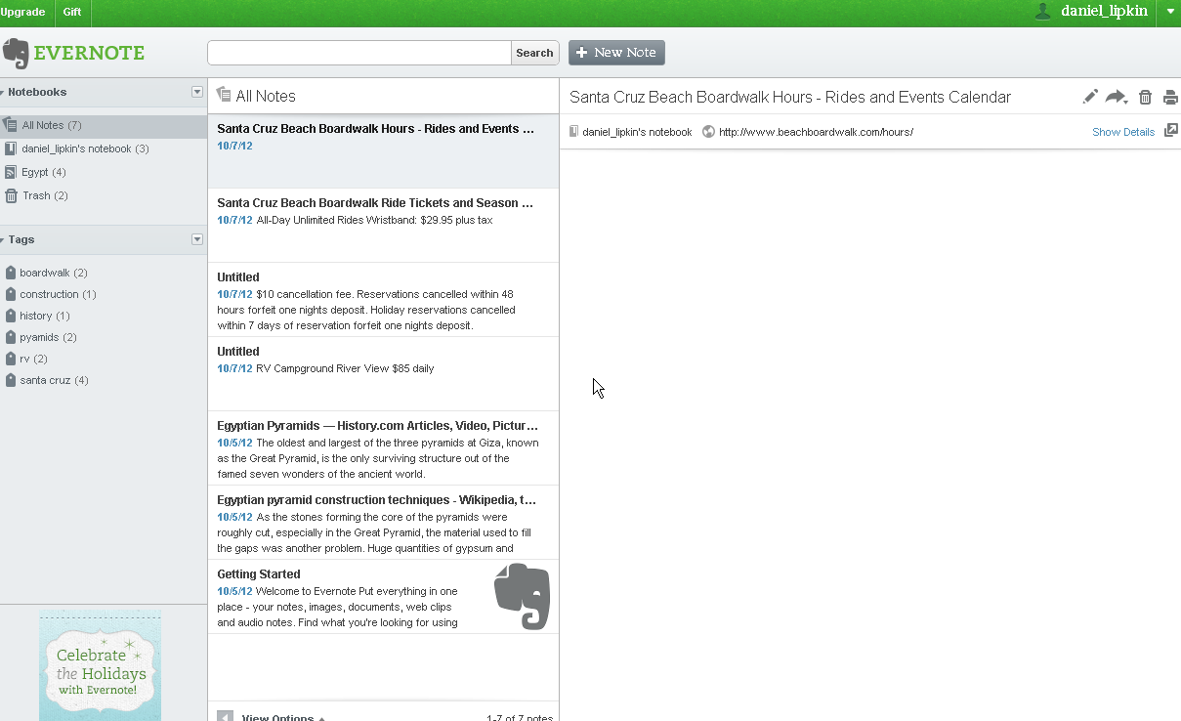

I also think they did a very nice job with their browser extension:

